SQL Data Analysis on Covid19 Dataset
1 Total Confirmed Cases and Deaths by Country
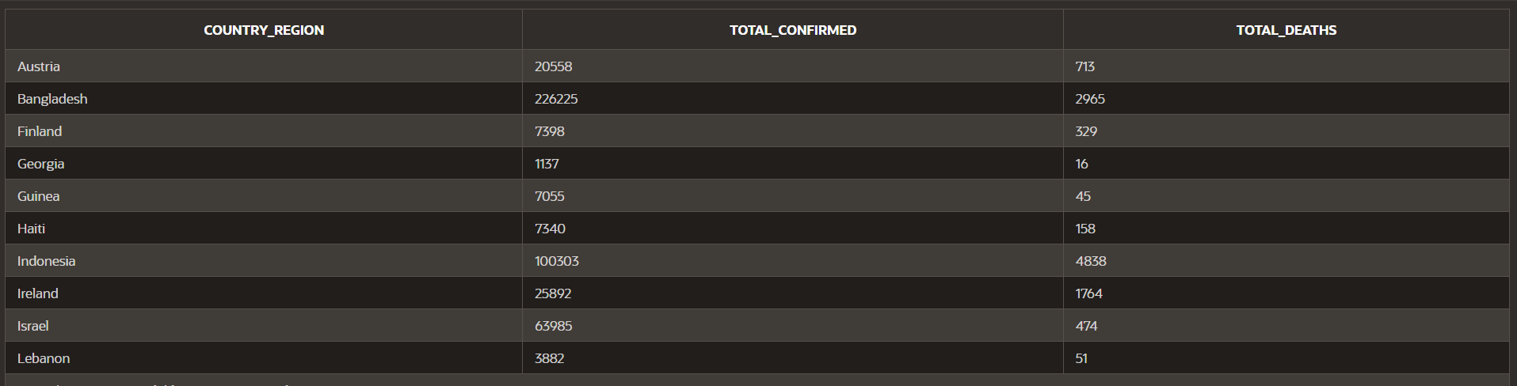
OUTPUT:

2 Top 10 Countries with the Highest New Cases
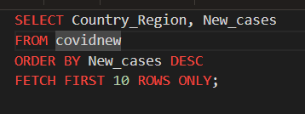
OUTPUT:
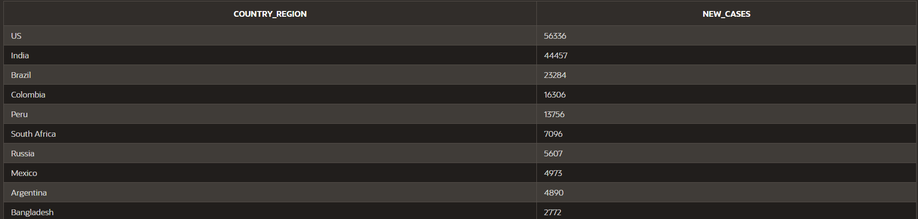
3 Countries with More than 100,000 Active Cases
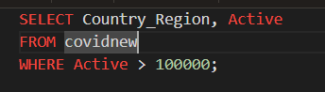
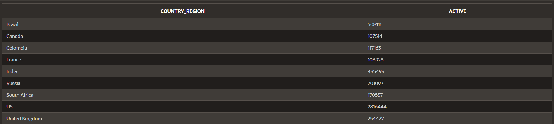
OUTPUT:

4 Total Recoveries by WHO Region
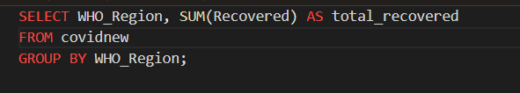
OUTPUT:
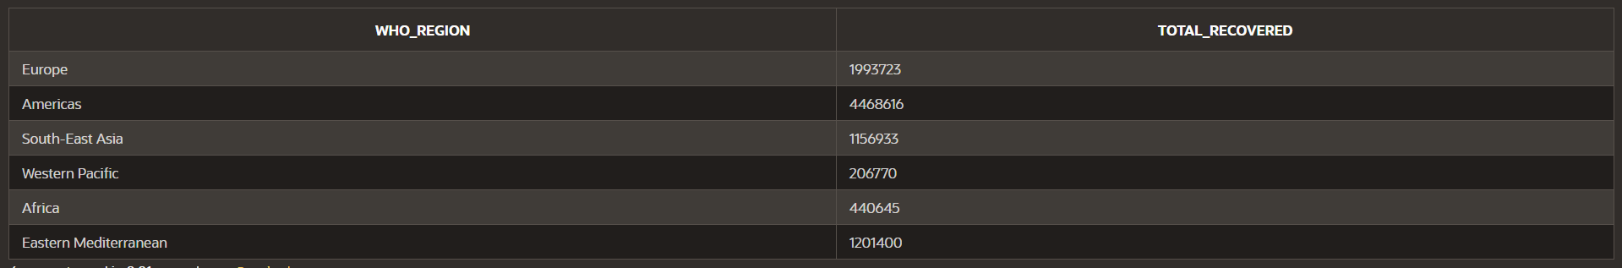
5 Countries with a Recovery Rate Higher Than 80%
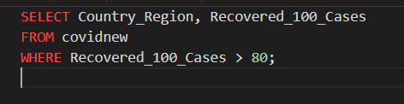
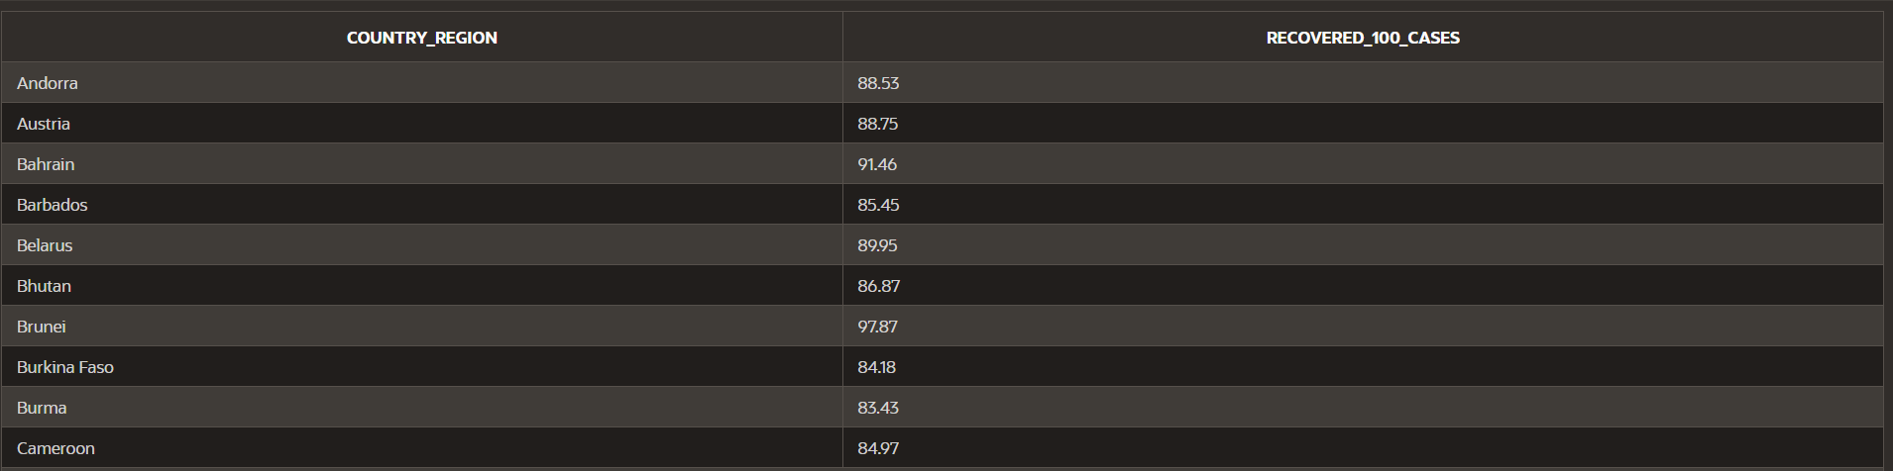
OUTPUT:

6 Average Death Rate Across All Countries
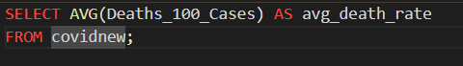
OUTPUT:

7 Countries with the Highest Weekly Percentage Increase in Cases
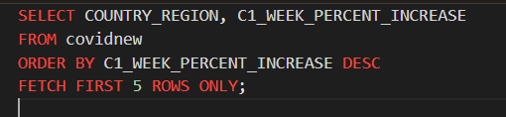
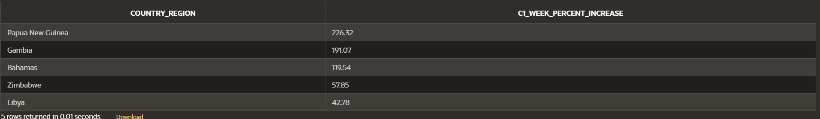
OUTPUT:

8 Countries with the Largest Weekly Change in Confirmed Cases
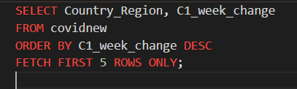
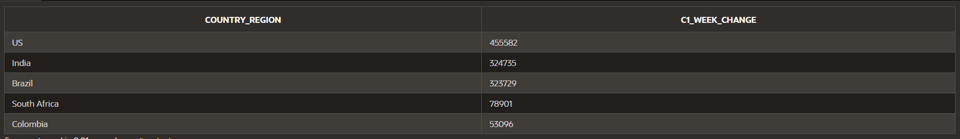
OUTPUT:

9 Calculate the Case Fatality Rate (CFR) for Each Country
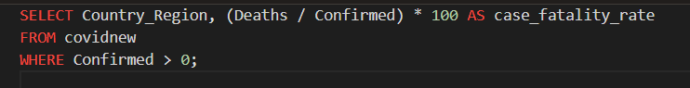
OUTPUT:
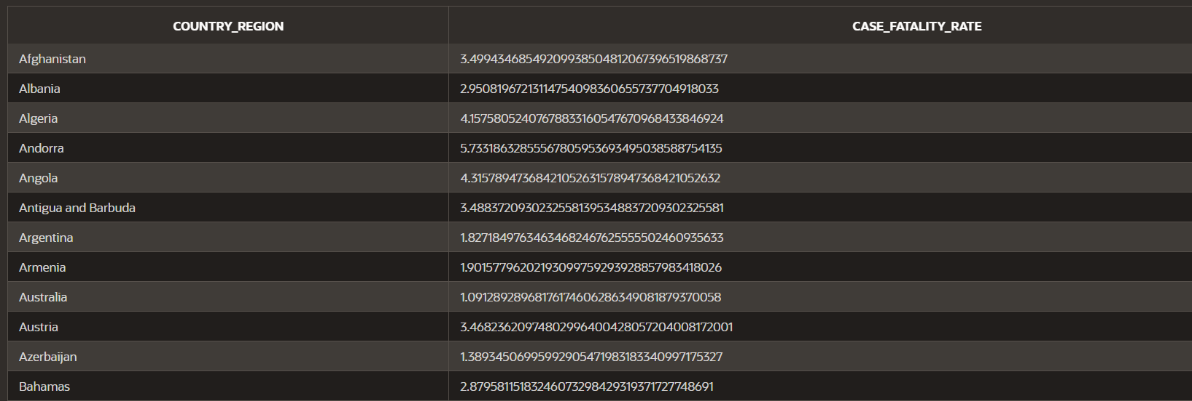

10 Total Cases and Deaths per WHO Region, Ranked by Total Deaths
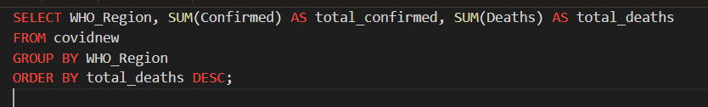
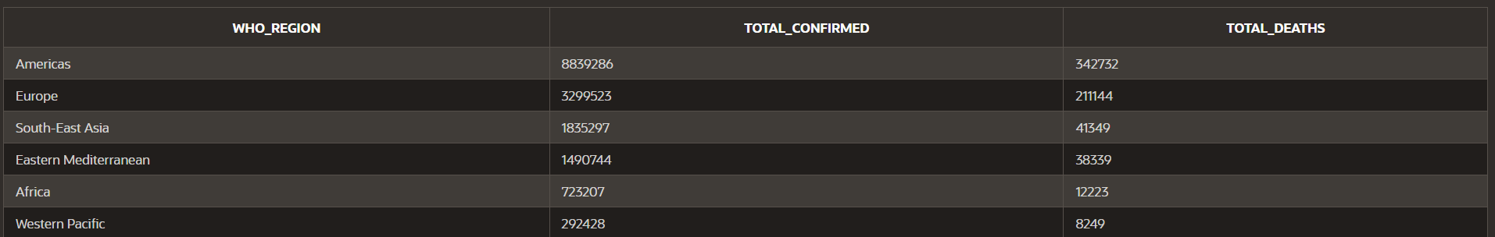
OUTPUT:

11 Countries Where the Death Rate Exceeds the Recovery Rate

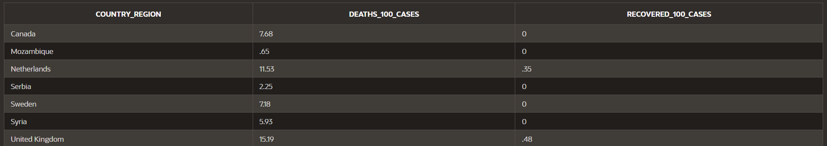
OUTPUT:

12 Rank Countries by Total Confirmed Cases and Show the Top 5
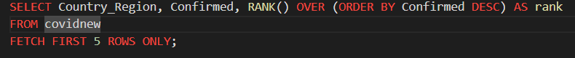
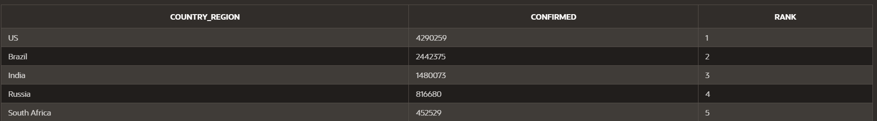
OUTPUT:

13 WHO Regions with a Recovery Rate Below 75%
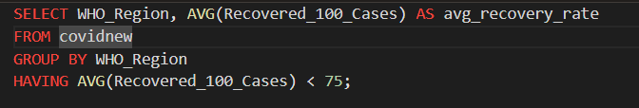
OUTPUT:

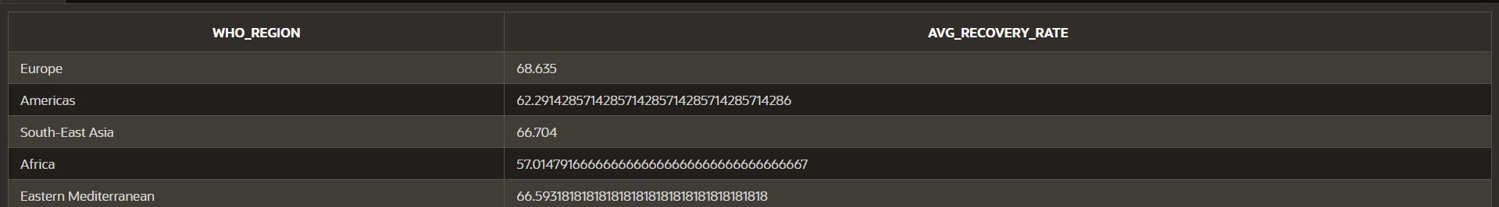
14 Countries with the Highest Confirmed-to-Death Ratio
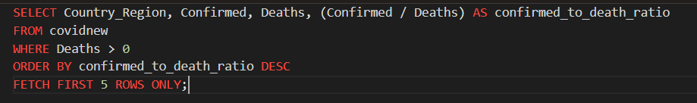
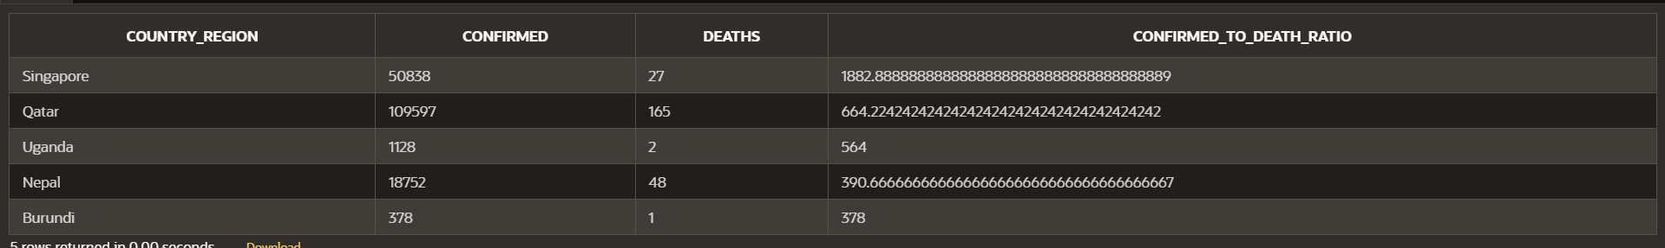
OUTPUT:

15 7-Day Rolling Average of New Cases for Each Country
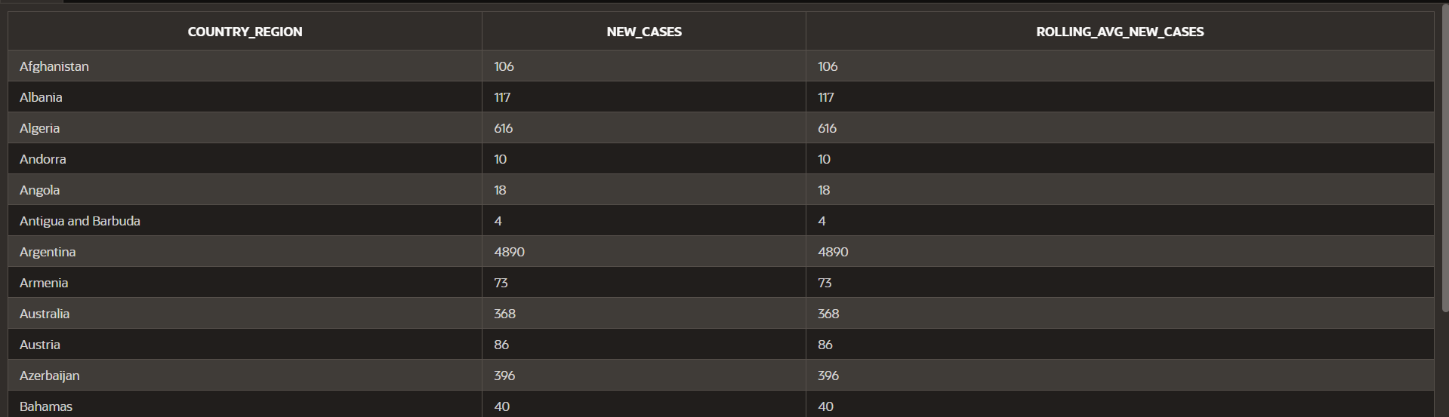
OUTPUT:
16 Countries with the Largest Decrease in Active Cases Over the Last Week
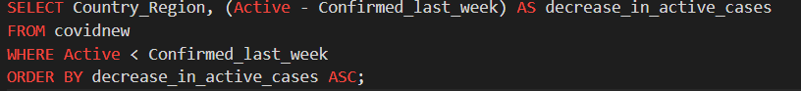
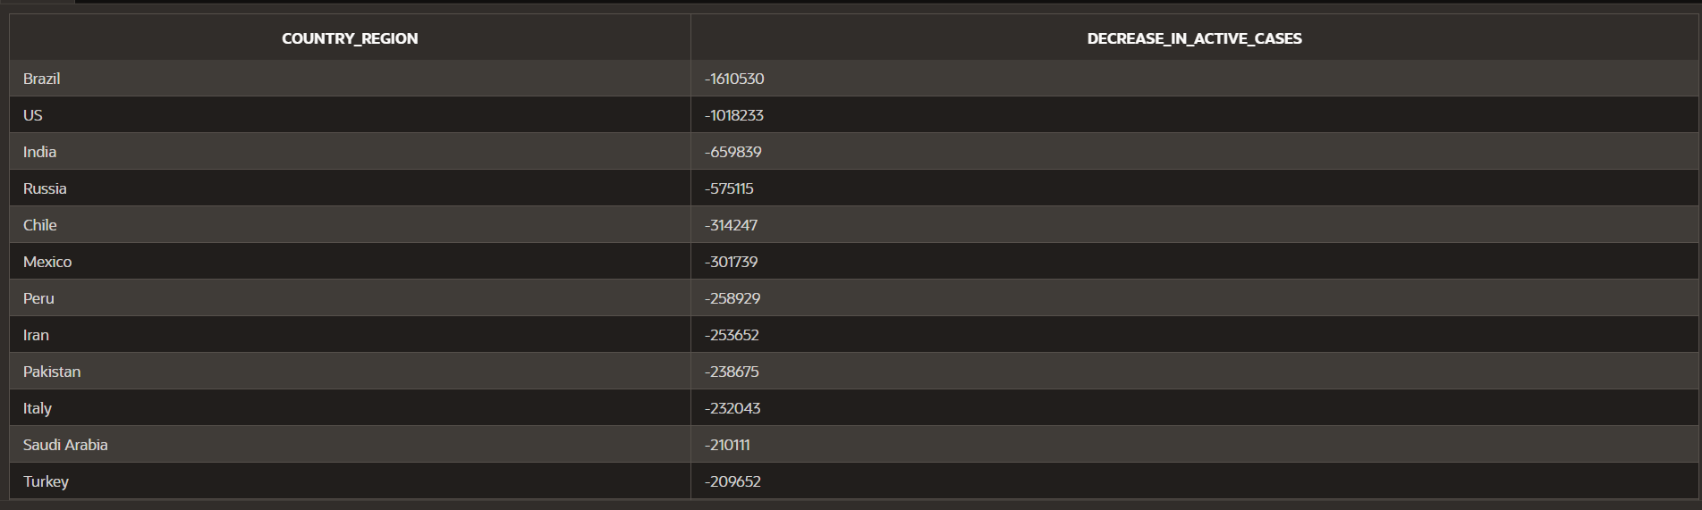
OUTPUT:
17 Countries with the Highest Death Proportion Compared to New Cases
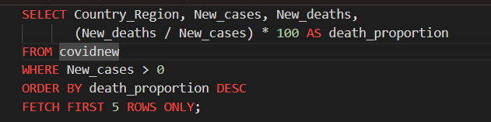
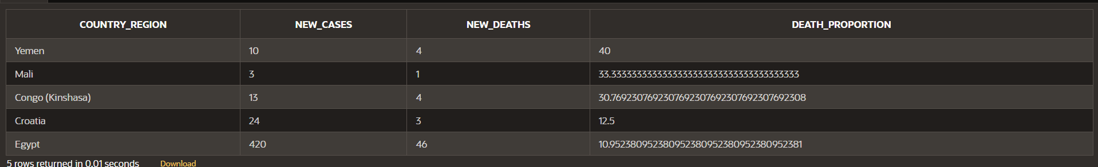
OUTPUT:

18 Top 5 WHO Regions by Case Fatality Rate (Deaths / Confirmed)
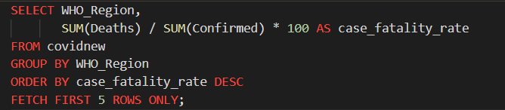
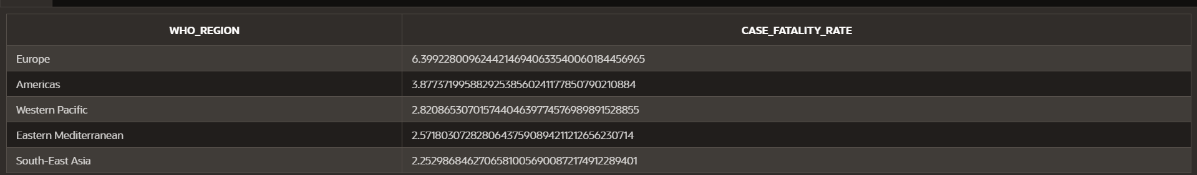
OUTPUT:

